Deep Learning project Pascal VOC

Gary Ong 1002758

Model: Pretrained resnet18

Last layer FC (512,20)

Loss: BCE with logits loss

Optimizer: SGD Lr = 0.005

Scheduler: None

Image size 224x224 Plain resize no crop

Epoch: 25

Batch size: 16

No augmentation, ImageNet normalization numbers

MAP Score 0.8242

+ Random Horizontal Flip

+ Random Erase

MAP Score 0.8306

Loss /precision against epoch for model

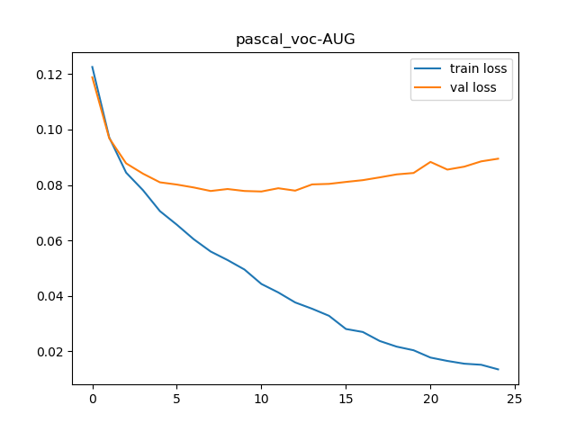

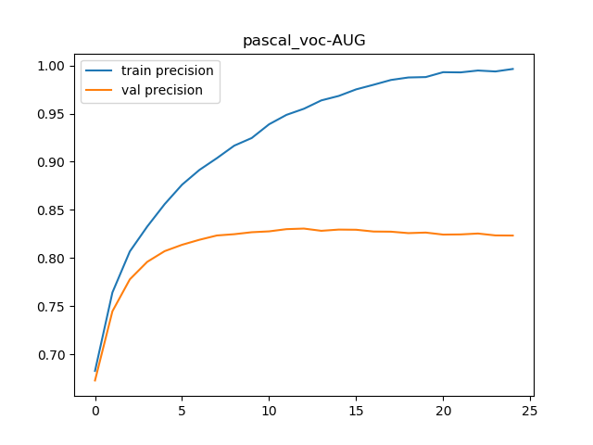

Model overfits quickly. Best score from validation set used for evaluation.

To see best and worst images go to the folder BestAndWorst5.

Here are the scores for MAP for each class and final macro average.

|  |  |
| --- | --- |
| class | MAP |
| aeroplane | 0.967 |
| bicycle | 0.862 |
| bird | 0.938 |
| boat | 0.872 |
| bottle | 0.597 |
| bus | 0.929 |
| car | 0.823 |
| cat | 0.954 |
| chair | 0.74 |
| cow | 0.759 |
| diningtable | 0.667 |
| dog | 0.904 |
| horse | 0.87 |
| motorbike | 0.892 |
| person | 0.955 |
| pottedplant | 0.602 |
| sheep | 0.856 |
| sofa | 0.624 |
| train | 0.943 |
| tvmonitor | 0.861 |
| macro avg all | 0.831 |

Macro averaged graph

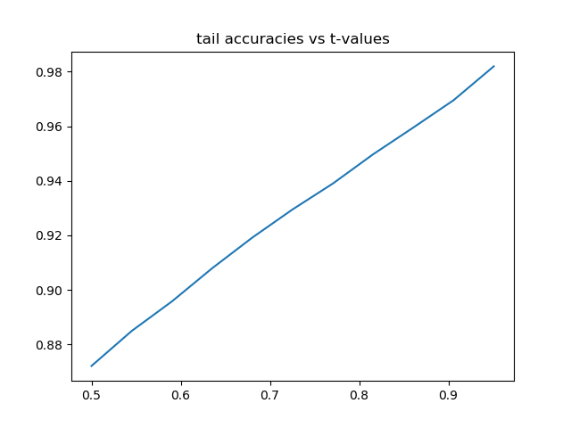

Tail accuracies of each class at each t values.

Maximum t is taken from min of max (fx) of each class.

|  |  |  |  |  |  |  |  |  |  |  |  |  |  |  |  |  |  |  |  |  |  |  |  |  |  |  |  |  |  |  |  |  |  |  |  |  |  |  |  |  |  |  |  |  |  |  |  |  |  |  |  |  |  |  |  |  |  |  |  |  |  |  |  |  |  |  |  |  |  |  |  |  |  |  |  |  |  |  |  |  |  |  |  |  |  |  |  |  |  |  |  |  |  |  |  |  |  |  |  |  |  |  |  |  |  |  |  |  |  |  |  |  |  |  |  |  |  |  |  |  |  |  |  |  |  |  |  |  |  |  |  |  |  |  |  |  |  |  |  |  |  |  |  |  |  |  |  |  |  |  |  |  |  |  |  |  |  |  |  |  |  |  |  |  |  |  |  |  |  |  |  |  |  |  |  |  |  |  |  |  |  |  |  |  |  |  |  |  |  |  |  |  |  |  |  |  |  |  |  |  |  |  |  |  |  |  |  |  |  |  |  |  |  |  |  |  |  |  |  |  |  |  |  |  |  |  |  |  |  |  |  |  |  |  |  |  |  |  |  |  |  |  |  |  |  |  |  |  |  |  |  |  |  |  |  |  |  |  |  |  |  |  |  |  |  |  |  |  |  |  |  |  |  |  |  |  |  |  |  |  |  |  |  |  |  |
| --- | --- | --- | --- | --- | --- | --- | --- | --- | --- | --- | --- | --- | --- | --- | --- | --- | --- | --- | --- | --- | --- | --- | --- | --- | --- | --- | --- | --- | --- | --- | --- | --- | --- | --- | --- | --- | --- | --- | --- | --- | --- | --- | --- | --- | --- | --- | --- | --- | --- | --- | --- | --- | --- | --- | --- | --- | --- | --- | --- | --- | --- | --- | --- | --- | --- | --- | --- | --- | --- | --- | --- | --- | --- | --- | --- | --- | --- | --- | --- | --- | --- | --- | --- | --- | --- | --- | --- | --- | --- | --- | --- | --- | --- | --- | --- | --- | --- | --- | --- | --- | --- | --- | --- | --- | --- | --- | --- | --- | --- | --- | --- | --- | --- | --- | --- | --- | --- | --- | --- | --- | --- | --- | --- | --- | --- | --- | --- | --- | --- | --- | --- | --- | --- | --- | --- | --- | --- | --- | --- | --- | --- | --- | --- | --- | --- | --- | --- | --- | --- | --- | --- | --- | --- | --- | --- | --- | --- | --- | --- | --- | --- | --- | --- | --- | --- | --- | --- | --- | --- | --- | --- | --- | --- | --- | --- | --- | --- | --- | --- | --- | --- | --- | --- | --- | --- | --- | --- | --- | --- | --- | --- | --- | --- | --- | --- | --- | --- | --- | --- | --- | --- | --- | --- | --- | --- | --- | --- | --- | --- | --- | --- | --- | --- | --- | --- | --- | --- | --- | --- | --- | --- | --- | --- | --- | --- | --- | --- | --- | --- | --- | --- | --- | --- | --- | --- | --- | --- | --- | --- | --- | --- | --- | --- | --- | --- | --- | --- | --- | --- | --- | --- | --- | --- | --- | --- | --- | --- | --- | --- | --- | --- | --- | --- | --- | --- | --- | --- | --- | --- | --- | --- | --- | --- | --- | --- | --- | --- | --- | --- | --- | --- | --- | --- | --- | --- |
| |  |  |  |  |  |  |  |  |  |  |  |  |  |  |  |  |  |  |  |  |  |  | | --- | --- | --- | --- | --- | --- | --- | --- | --- | --- | --- | --- | --- | --- | --- | --- | --- | --- | --- | --- | --- | --- | | t-values | aeroplane | bicycle | bird | boat | bottle | bus | car | cat | chair | cow | diningtable | dog | horse | motorbike | person | pottedplant | sheep | sofa | train | tvmonitor | average | | 0.5 | 0.87 | 0.87 | 0.87 | 0.87 | 0.87 | 0.87 | 0.87 | 0.87 | 0.87 | 0.87 | 0.87 | 0.87 | 0.87 | 0.87 | 0.87 | 0.87 | 0.87 | 0.87 | 0.87 | 0.87 | 0.87 | | 0.545091396 | 0.88 | 0.88 | 0.88 | 0.88 | 0.88 | 0.88 | 0.88 | 0.88 | 0.88 | 0.88 | 0.88 | 0.88 | 0.88 | 0.88 | 0.88 | 0.88 | 0.88 | 0.88 | 0.88 | 0.88 | 0.88 | | 0.590182792 | 0.9 | 0.9 | 0.9 | 0.9 | 0.9 | 0.9 | 0.9 | 0.9 | 0.9 | 0.9 | 0.9 | 0.9 | 0.9 | 0.9 | 0.9 | 0.9 | 0.9 | 0.9 | 0.9 | 0.9 | 0.9 | | 0.635274188 | 0.91 | 0.91 | 0.91 | 0.91 | 0.91 | 0.91 | 0.91 | 0.91 | 0.91 | 0.91 | 0.91 | 0.91 | 0.91 | 0.91 | 0.91 | 0.91 | 0.91 | 0.91 | 0.91 | 0.91 | 0.91 | | 0.680365584 | 0.92 | 0.92 | 0.92 | 0.92 | 0.92 | 0.92 | 0.92 | 0.92 | 0.92 | 0.92 | 0.92 | 0.92 | 0.92 | 0.92 | 0.92 | 0.92 | 0.92 | 0.92 | 0.92 | 0.92 | 0.92 | | 0.72545698 | 0.93 | 0.93 | 0.93 | 0.93 | 0.93 | 0.93 | 0.93 | 0.93 | 0.93 | 0.93 | 0.93 | 0.93 | 0.93 | 0.93 | 0.93 | 0.93 | 0.93 | 0.93 | 0.93 | 0.93 | 0.93 | | 0.770548376 | 0.94 | 0.94 | 0.94 | 0.94 | 0.94 | 0.94 | 0.94 | 0.94 | 0.94 | 0.94 | 0.94 | 0.94 | 0.94 | 0.94 | 0.94 | 0.94 | 0.94 | 0.94 | 0.94 | 0.94 | 0.94 | | 0.815639772 | 0.95 | 0.95 | 0.95 | 0.95 | 0.95 | 0.95 | 0.95 | 0.95 | 0.95 | 0.95 | 0.95 | 0.95 | 0.95 | 0.95 | 0.95 | 0.95 | 0.95 | 0.95 | 0.95 | 0.95 | 0.95 | | 0.860731168 | 0.96 | 0.96 | 0.96 | 0.96 | 0.96 | 0.96 | 0.96 | 0.96 | 0.96 | 0.96 | 0.96 | 0.96 | 0.96 | 0.96 | 0.96 | 0.96 | 0.96 | 0.96 | 0.96 | 0.96 | 0.96 | | 0.905822564 | 0.97 | 0.97 | 0.97 | 0.97 | 0.97 | 0.97 | 0.97 | 0.97 | 0.97 | 0.97 | 0.97 | 0.97 | 0.97 | 0.97 | 0.97 | 0.97 | 0.97 | 0.97 | 0.97 | 0.97 | 0.97 | | 0.95091396 | 0.98 | 0.98 | 0.98 | 0.98 | 0.98 | 0.98 | 0.98 | 0.98 | 0.98 | 0.98 | 0.98 | 0.98 | 0.98 | 0.98 | 0.98 | 0.98 | 0.98 | 0.98 | 0.98 | 0.98 | 0.98 | |  |  |  |  |  |  |  |  |  |  |  |  |  |  |  |  |  |  |  |  |  |
|  |  |  |  |  |  |  |  |  |  |  |  |  |  |  |  |  |  |  |  |  |  |
|  |  |  |  |  |  |  |  |  |  |  |  |  |  |  |  |  |  |  |  |  |  |
| How to run code:  To train the model run **train_model.py**  The first few lines contain some stuff in CAPS that you might want to change.  Produces saved model and loss precision graphs in directory.  To evaluate the model run **eval_model.py**  The first few lines contain some stuff in CAPS that you might want to change.  Produces csv file for MAP for each class and macro averaged and csv file for tail accuracies.  Also produces 5 classes with 5 best and 5 worst images.  All functions required written in **pascal_functions.py.** Designed to be run independently.  Dataset **PacalVocDataset.py** modified from starter code.  Training code takes about 3 min per epoch on laptop GTX 1050ti  Testing code takes about 1 min on laptop GTX 1050ti. |  |  |  |  |  |  |  |  |  |  |  |  |  |  |  |  |  |  |  |  |  |
|  |  |  |  |  |  |  |  |  |  |  |  |  |  |  |  |  |  |  |  |  |  |
|  |  |  |  |  |  |  |  |  |  |  |  |  |  |  |  |  |  |  |  |  |  |
|  |  |  |  |  |  |  |  |  |  |  |  |  |  |  |  |  |  |  |  |  |  |
|  |  |  |  |  |  |  |  |  |  |  |  |  |  |  |  |  |  |  |  |  |  |
|  |  |  |  |  |  |  |  |  |  |  |  |  |  |  |  |  |  |  |  |  |  |
|  |  |  |  |  |  |  |  |  |  |  |  |  |  |  |  |  |  |  |  |  |  |
|  |  |  |  |  |  |  |  |  |  |  |  |  |  |  |  |  |  |  |  |  |  |
|  |  |  |  |  |  |  |  |  |  |  |  |  |  |  |  |  |  |  |  |  |  |